FIFA WORLD CUP

### - Context:

The FIFA World Cup is a global football competition contested by the various football-playing nations of the world. It is contested every four years and is the most prestigious and important trophy in the sport of football.

### - Content:

FIFA WORLD CUP Data set contain 2 tables

1. Cup table ( [link](world_cups.csv) ) :

Columns ( Year, Host Country, Winner, Runners-Up, Third, Fourth, Goals Scored, Qualified Teams, Matches Played,

Top_Scorer, Goals ).

1. Matches table ( [link](world_cup_matches.csv) )

Columns (ID, Year, Date, Stage, Home Team, Home Goals, Away Goals, Away Team, Win Conditions, Host Team).

And data_dictionary table to describe all columns in dataset.

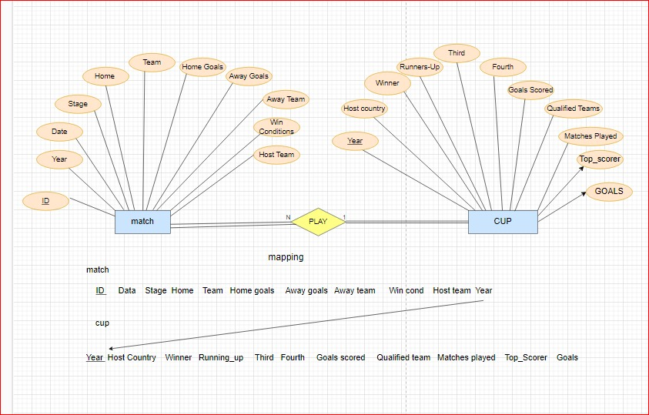ERD :

### - Insights:

We answered some questions ….

1- Which Countries Hosted the World Cup and Won?

2- which world cup has highest goals scored?

3- which country scored a highest goal outside home?

5- which Final match has a highest-goals scored?

6- Most Team Won The World Cups.

(The Most Teams Won The World Cups)?

7- Which Countries Achieve The Specific Position?

8- Who Win The Cup in That Year?

9- which countries won the world cup in 2000s?

10- Average Goals Scored In World Cups and Who Is The Country?

11- Which team has played the most matches in world cup history?

12- What is the highest number of goals scored by a player in a single tournament?

13- MOST SCORED MATCH.

14- Top 5 Countries Scored Goals.

15- number Of Goals For Team In Specific Stage.

16- Number Of Appearance Of The Team For Each Cup.

17- NUMBER OF MATCHES PLAYED BY TEAM.

18- Which Country Win and Which Country Host The specific Cup?

19- Prevent The Update in dataset(Trigger).

20- HIGHEST SCORE MATCH.

21- Top Country Won In a Specific Position?

### - Tools and Technologies Used:

● SQL Server 2019

● Advanced SQL Queries:

- Functions:

- getwinner - N_Matches_Year

- Position - N_Matches

- GETDATA

- Stored Procedures:

- HostAndWin - Final_Highest_Goal - Most_Matches_Played

- HighGoalsCup - Champ_Of_WC - High_Goals_Player

- HighGoalsOut - The_Winner - Most_Scored_Match

- HighGoalsIn - The_2000s_Winners - Top5TeamsGoals

- Goal_Stage - Top_Team

- Triggers ( up_host )

- VIEW ( H_A_Goals )

- Window functions ( rank(), dense_rank () )

- CTE

- Subquires